September 12, 2024
Ref: IIH/MD/2024/09/005

His Excellency,
The Executive Governor of Kwara State,
Government House,
Ahmadu Bello Way,
GRA, Ilorin, Kwara State

Your Excellency Sir,
REQUEST FOR APROVAL TO COMMENCE PROCESSING OF CERTIFICATE OF OCCUPANCY FOR ILORIN INNOVATION HUB LAND
Sequel to previous change of ownership of Ilorin Innovation Hub Ltd - RC 1664691 (to be fully owned by the Kwara State Government via the Ministry of Finance Incorporated) and further consolidation of the corporate entity’s assets, I write to request for your approval for commencement of processing of the Certificate of Occupancy for the land lying and being within that expanse land known and described as the Kwara ICT Hub Project of the Ministry of Business Innovation & Technology (within the Kwara Hotel premises and owned by the Kwara State Government) in the name of the company Ilorin Innovation Hub Ltd. This will allow clear asset and company valuation.

Thank you once again Your Excellency for your undying support.

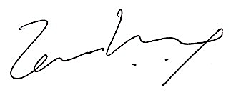
Yours sincerely,

Temi Kolawole
Managing Director

